IIHT

Tweet App

Contents

1 Problem Statement 2

2 Application Architecture 2

3 Tool Chain 2

4 Business-Requirement: 3

4.1 Presentation 3

4.2 Database, storage 3

4.3 Debugging & Troubleshooting 3

5 Rubrics/Expected Deliverables 4

6 Problem Statement 4

7 Proposed Tweet App Wireframe 5

8 Tweet Component Sketch 5

9 Application Architecture 6

10 Cloud Architecture 6

11 Tool Chain 7

12 Business-Requirement: 8

13 Rubrics/Expected Deliverables 9

13.1 Rest API (Products & Frameworks -> Compute & Integration): 9

13.2 Database (Products & Frameworks -> Database & Storage): 9

13.3 Maven (Tooling): 10

13.4 Messaging (Products & Frameworks -> Compute & Integration): 10

13.5 Log/ Monitoring (Products & Frameworks -> Governance & Tooling): 10

13.6 Debugging & Troubleshooting 10

13.7 Code Quality 10

13.8 Secured Coding 11

14 Platform 11

14.1 Compute 11

14.2 Compute, Identity & Compliance, Security& Content Delivery 11

15 Methodology 11

15.1 Agile 11

# Problem Statement

Tweet App is app for registered users to post new tweets, view tweets by other users.

Guest users cannot see any tweets.

The core modules of tweet app are:

1. User registration and login
2. Post tweet
3. View all tweets (all from logged in users account)
4. View users and their respective tweets
5. Forgot password option to reset password.

Reset password algorithm should be written using typescript and transpile into javascript.

JavaScript containing reset password algorithm, should be executed by java when reset password is required.

# Application Architecture

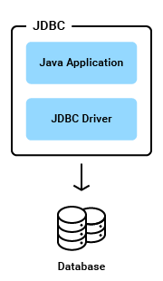

# Tool Chain

|  |  |  |
| --- | --- | --- |
| Competency | Skill | Skill Detail |
| Programming Languages | Application Language | Java |
|  |  | Typescript  Javascript |
|  | Data structures and Algorithms | Data structures and Algorithms |
|  | Database Access | SQL |

# Business-Requirement:

Write a program for Tweet App with below guidelines:

|  |
| --- |
| Presentation |
| 1. A user can register and login. 2. Use below details while registration:    1. first_name (required)    2. last_name (optional)    3. gender (required)    4. dob (optional, dd-MM-yyyy)    5. email (required, email will must be used as login-id so must be unique)    6. password (required) 3. A logged-in user can change his password (old password is required). 4. A logged-in user:    1. Can post new tweet.    2. Can view all his tweets.    3. Can view all registered users and their respective tweets. 5. A user can reset old password. |

|  |
| --- |
| Database, storage |
| 1. As the twitter application I should –    1. Create user when successful registration is done    2. Create new tweet when user tweets    3. Find all uses and their tweets    4. Update user’s password |

|  |
| --- |
| Debugging & Troubleshooting |
| 1. As the programmer I should:    1. Debug & Troubleshoot the code which has bugs with breakpoints / pause    2. Ensure optimal resource utilization & close unneeded connections    3. Ensure all unhandled exceptions are addressed    4. Query the database only for the necessary information (user info/tweets etc) with proper indexes & order. |

# Rubrics/Expected Deliverables

* Implement java 8 features – lambda, stream, map, etc.
* Email id should be used as username/userid
* Use db.properties to store database parameters.
* Package Structure for project will be like com.tweetapp.* with proper naming conventions for package and beans.
* Use dao layer, service layer.
* Use proper layering – database interaction code should be only in DAO classes. DAO classes should not have UI/Business logic. Service classes will have all the business logic.
* Input validations must be handled
* Use custom exception and show a valid error message to user if something goes wrong.
* Use javascript algorithm to reset password. JavaScript code to be executed when reset password is required.
* Build the project.

# Problem Statement

You've already made a miniature version of the Tweet App in component 1. As a part of component 2, you'll be enhancing this app with a complete middleware & framework. The updated specs are as listed below

Tweet App is an application for registered users to post new tweets, reply to tweets, like/unlike tweets.

Guest users cannot see any tweets.

The core modules of tweet app are:

1. User registration and login
2. Post tweet
3. View users/handles and their respective tweets

The scope includes developing the application using toolchain mentioned below.

# Proposed Tweet App Wireframe

* + - 1. UI needs improvisation and modification as per given use case.
      2. 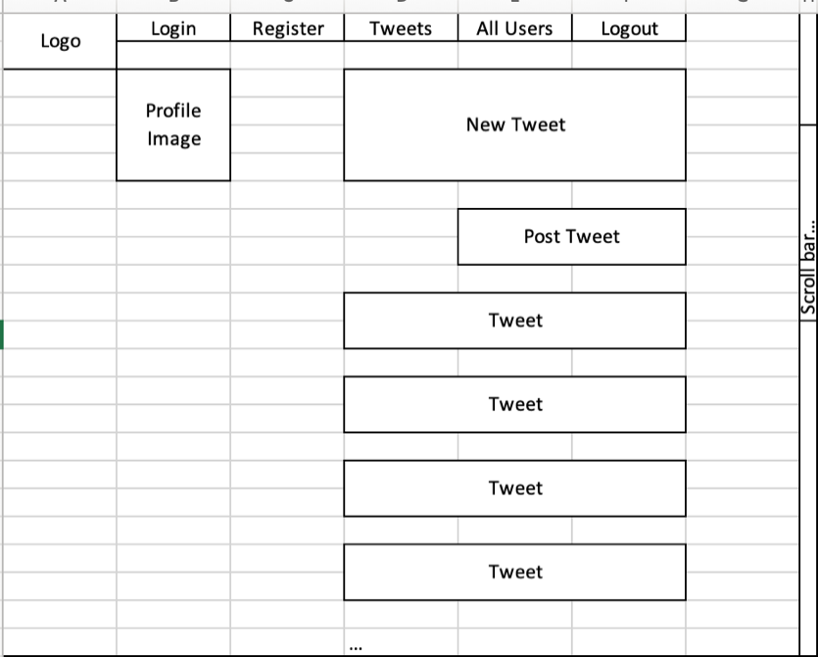

# Tweet Component Sketch

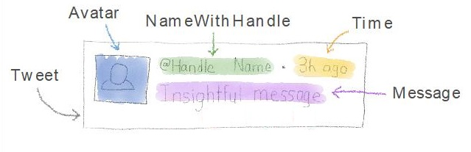

# Application Architecture

Sonarcube

index.html

App Module (Root Module)

Root Component

Tweet App Component

Code Quality (Engineering & Quality)

Tweet App Services

Presentation (Products & Frameworks)

GIT

Docker

Spring Boot Rest API

MQ Producer

Junit

MQ Consumer

Logstash

Compute & Integration (Products & Frameworks)

OpenAPI/Swagger

Actuator

Compute & Integration (Products & Frameworks)

Prometheus/Grafana

DB

Governance & Tooling   
(Products & Frameworks)

Database & Storage (Products & Frameworks)

# Cloud Architecture

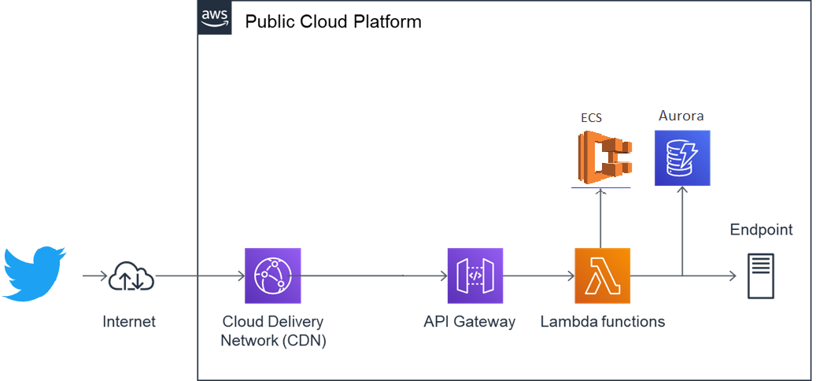

# Tool Chain

|  |  |  |
| --- | --- | --- |
| Competency | Skill | Skill Detail |
| Engineering Mindset | Networking and Content Delivery |  |
|  | Ways of Working |  |
|  | Consulting Mindset |  |
|  | DevOps |  |
| Programming Languages | Application Language | Java |
| Products & Frameworks | Presentation | Angular |
|  |  | Karma & Jasmine |
|  | Compute & Integration | Spring Boot |
|  |  | Kafka/RabbitMQ/ActiveMQ/KubeMQ |
|  |  | Docker |
|  | Database & Storage | MongoDB |
|  | Governance & Tooling | Git |
|  |  | Maven |
|  |  | Junit |
|  |  | Mockito |
|  |  | Logstash |
|  |  | Prometheus & Grafana |
| Engineering Quality | Code Quality | Sonar Cube |
| Platform | Cloud Tools | AWS ECS |
|  |  | AWS DynamoDB/Aurora |
|  |  | AWS Lambda |
|  |  | AWS ElasticCache |
|  |  | AWS CodeDeploy |
|  |  | AWS API Gateway |
|  |  | AWS ELB(Elastic Load Balancer) |
|  |  | AWS SNS |

# Business-Requirement:

As an application developer, develop frontend, middleware and deploy the Tweet App (Single Page App) with below guidelines:

|  |  |  |
| --- | --- | --- |
| User  Story # | User Story Name | User Story |
| US_01 | Registration and Login | As a user I should be able to login/Register in the tweet application  Acceptance criteria:   1. A logged-in user can reset their password so they can login, even if they forget their password. 2. A logged-in user:    1. Cannot change their username.    2. Can logout from their account. 3. As a user I should be able to furnish following details at the time of registration    1. First Name    2. Last Name    3. Email    4. Login Id    5. Password    6. Confirm Password    7. Contact Number 4. All details fields must be mandatory 5. Login Id and Email must be unique 6. Password and Confirm Password must be same 7. If any constraint is not satisfied, validation message must be shown |
| US_02 | Post Tweet | As a user I should be able to post a tweet  Acceptance criteria:   * 1. Tweet should not go beyond 144 characters.   2. Tweet can optionally be associated with a tag which should not go beyond 50 characters |
| US_03 | View and Reply Tweet | As a user I should be able to view others tweet and reply to it.  Acceptance criteria:   * 1. View others tweet and reply   2. Others tweet should display original tweet with all the reply   3. Tweet and reply must have user name and time of post displayed along.   4. Reply should not go beyond 144 characters   5. I should be optionally able to add a tag while replying |

# Rubrics/Expected Deliverables

## Rest API (Products & Frameworks -> Compute & Integration):

* 1. Use Spring Boot to version and implement the REST endpoints.
  2. Implement HTTP methods like GET, POST, PUT, DELETE, PATCH to implement RESTful resources:

|  |  |  |
| --- | --- | --- |
| **POST** | **/api/v1.0/tweets/register** | **Register as new user** |
| **GET** | **/api/v1.0/tweets/login** | **Login** |
| **GET** | **/api/v1.0/tweets/<username>/forgot** | **Forgot password** |
| **GET** | **/api/v1.0/tweets/all** | **Get all tweets** |
| **GET** | **/api/v1.0/tweets/users/all** | **Get all users** |
| **GET** | **/api/v/1.0/tweets/user/search/username\*** | **Search by username** |
| **GET** | **/api/v1.0/tweets/username** | **Get all tweets of user** |
| **POST** | **/api/v1.0/tweets/<username>/add** | **Post new tweet** |
| **PUT** | **/api/v1.0/tweets/<username>/update/<id>** | **Update tweet** |
| **DELETE** | **/api/v1.0/tweets/<username>/delete/<id>** | **Delete tweet** |
| **PUT** | **/api/v1.0/tweets/<username>/like/<id>** | **Like tweet** |
| **POST** | **/api/v1.0/tweets/<username>/reply/<id>** | **Reply to tweet** |

* 1. **\*username may be partial or complete username**
  2. Use necessary configuration in place for REST API in application.properties or bootstrap.properties or application.yml; whichever is applicable.
  3. Package Structure for Spring Boot Project will be like com.tweetapp.* with proper naming conventions for package and beans.
  4. Use configuration class annotated with @Configuration and @Service for business layer.
  5. Use constructor-based dependency injection in few classes and setter-based dependency injection in few classes.
  6. Follow Spring Bean Naming Conventions

## Database (Products & Frameworks -> Database & Storage):

1. As an application developer:
   1. Implement ORM with Spring Data MongoRepositoryand MongoDB. For complex and custom queries, create custom methods and use @Query, Aggregations (AggregationOperation, MatchOperation, AggregationResults), implementation of MongoTemplateetc as necessary.
   2. Have necessary configuration in place for REST API in application.properties or bootstrap.properties or application.yml OR Java based configuration; whichever is applicable.

## Maven (Tooling):

* + - 1. As an application developer:
         1. Create the spring boot project using Maven CLI
         2. Generate Surefire test reports and share it as a part of deliverables
         3. Using Maven CLI generate the project documentation, and share it as a part of deliverables

## Messaging (Products & Frameworks -> Compute & Integration):

1. As an application developer:
   1. Have a centralized logging system
   2. Be able to communicate using a messaging infrastructure.
   3. Use Kafka/RabbitMQ/ActiveMQ/KubeMQTemplate for communication with Springboot and topics in Kafka/RabbitMQ/ActiveMQ/KubeMQ.
   4. Use Kafka/RabbitMQ/ActiveMQ/KubeMQ for messaging infrastructure and implement producers to write messages/tweets to topic and consumers to read messages/tweets from topic.
   5. Configure Springboot app to log all logging messages to Kafka/RabbitMQ/ActiveMQ/KubeMQ.
   6. Configure all Kafka/RabbitMQ/ActiveMQ/KubeMQ related configuration needed for Spring Boot in *.properties or *.yml file.

## Log/ Monitoring (Products & Frameworks -> Governance & Tooling):

1. As an application developer:
   1. Containerize the complete application, which includes front-end, middleware and Kafka/RabbitMQ/ActiveMQ/KubeMQ (consumers and producers) using docker and Dockerfile.
   2. Use .dockerignore as necessary to avoid containerizing un-necessary packages.
   3. Integrate Spring Boot Actuator with Prometheus and Grafana to monitor middleware.
   4. Implement logs with logstash.
   5. Open the preconfigured Logstash in Kibana and check if it successfully connect to Elasticsearch Server.

## Debugging & Troubleshooting

1. Generate bug report & error logs - Report must be linkedwith final deliverableswhich should also suggest the resolutionfor the encountered bugs and errors.

## Code Quality

1. Associates should have written efficient code within acceptable limits of time and space complexity
2. Associates should have written clean code that is readable
3. Associates should have written testable code
4. Associate should have used the required Code Analyzer to ensure code quality and standard code style

## Secured Coding

1. Associates should have applied basic secure coding principles
2. Associates should have avoided deprecated functions
3. Associates should have used Checkmarx/Veracode as the secured coding tool

# Platform

## Compute

* + - 1. Use ECS CLI (as an alternative to AWS Management Console) for container management and deployment of spring boot application. You should be able to explain and demonstrate the same in interview.
      2. Use NoSQL instance of AWS DynamoDB/Aurora(SQL) as a database for the Tweet Application

## Compute, Identity & Compliance, Security& Content Delivery

1. Use AWS Lambda and AWS Aurora to build a backend process for handling requests for Tweet App.
2. Use Serverless Java Container using AWS ECS and run the tweet app created with Spring Boot inside AWS Lambda.
3. Use Amazon API Gateway to expose the lambda functions built in the previous step to be accessible on public internet.
4. Use AWS ELB to configure the auto-scaling container instances.
5. Configure AWS SNS to issue messages whenever a ELB scales-up and scale-down container instances

Note – Minimum two rest endpoints should be hosted in cloud

# Methodology

## Agile

1. As an application developer, use project management tool along to update progress as you start implementing solution.
2. As an application developer, the scope of discussion with mentor is limited to:
   1. Q/A
   2. New Ideas, New feature implementations and estimation.
   3. Any development related challenges
   4. Skill Gaps
   5. Any other pointers key to UI/UX and Middleware Development